ROCK, PAPER AND SCISSORS GAME

A Mini Project Presentation presented to the
College of Information Technology Education
PHINMA – University of Iloilo
Iloilo City

Submitted in partial fulfillment of the requirements for the degree of
Bachelor of Science in Information Technology
(ITE 260 – Computer Programming 1)

Members:
Feliciano, Ashly Marañon
Flaviano, Ariane Cabangal
Sapeda, John Mirben Escala
Tabuada, Jerald Jone Diza
Tagulino, Kean Vhenz

October 2026

INTRODUCTION
Description
The Rock, Paper, Scissors Game is a simple game developed using the Python programming language. In this game, the player chooses rock, paper, or scissors, while the computer randomly selects one of the three choices. The program compares the player's choice with the computer's choice to determine the winner.
The game follows three basic rules: rock beats scissors, scissors beats paper, and paper beats rock. If both the player and the computer choose the same option, the result is a tie.
This project demonstrates basic Python programming concepts such as variables, user input, conditional statements, loops, functions, and random selection. It also allows the player to play multiple rounds until they choose to quit.

OBJECTIVES OF THE STUDY
General Objective
To develop a miniature computer set using recyclable materials for educational demonstration.
Specific Objectives
Specifically, this project aims to:
1.To allow the player to choose rock, paper, or scissors.
2.To determine the winner by comparing the player's choice with the computer's random choice.
3.To apply basic Python programming concepts such as conditional statements, loops, and functions in developing the game.
Scope and Limitations
The project focuses on developing a text-based Rock, Paper, Scissors Game using Python. The program accepts the player's choice through keyboard input and generates the computer's choice randomly. It determines whether the player wins, loses, or gets a tie.
The game can be played repeatedly until the player decides to quit. It also checks invalid inputs and asks the player to enter a valid choice.
However, the program does not include graphics, online multiplayer, user accounts, or a database. It is designed for beginners who want to understand basic programming concepts.
DEFINITION OF TERMS
Python - A programming language used to create the game.
Variable - A container used to store information, such as the player's choice.
Input - Information entered by the player using the keyboard.
Random Selection - A process that allows the computer to select an option randomly.
Conditional Statement - A programming structure that uses if, elif, and else to make decisions.
Loop - A programming structure that repeats instructions until a condition is met.
Function - A reusable block of code that performs a specific task.
Text-Based Game - A game that uses text for instructions, choices, and results instead of graphics.

FLOW OF THE PROJECT
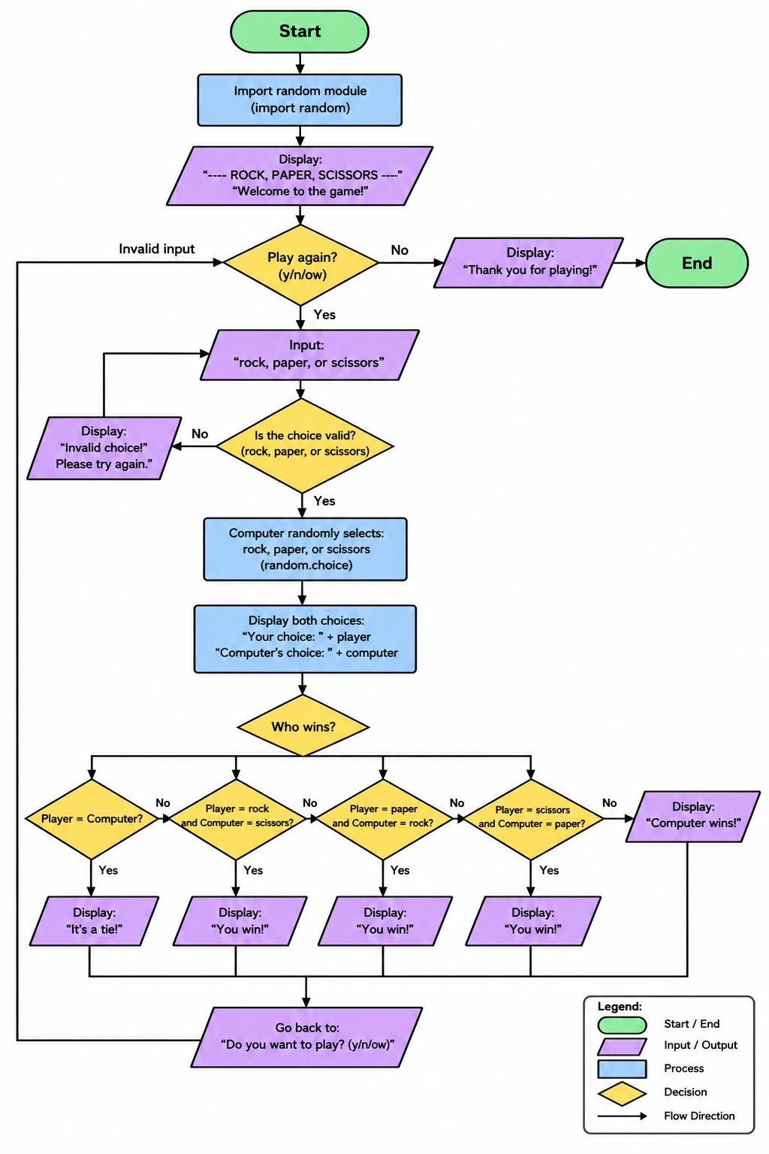
KEY FEATURES
The Rock, Paper, Scissors Game includes the following features:
1.Three Game Choices - The player can choose rock, paper, or scissors.
2.Random Computer Choice - The computer randomly selects one of the three options.
3.Winner Determination - The program determines whether the player wins, loses, or ties.
4.Input Validation - The program checks if the player's input is valid.
5.Replay Option - The player can play multiple rounds.
6.Quit Option - The player can end the game whenever they want.

CONCLUSION
The Rock, Paper, Scissors Game demonstrates how Python can be used to develop a simple and interactive game. Through this project, the programmer applies basic concepts such as variables, user input, random selection, conditional statements, loops, and functions.
The project also helps beginners improve their problem-solving and logical thinking skills. Overall, the game provides a practical way to understand the fundamentals of Python programming.
SOURCE CODE
